SIR SYED UNIVERSITY OF ENGINEERING & TECHNOLOGY
COMPUTER SCIENCE & INFORMATION TECHNOLOGY DEPARTMENT

Fall 2024
Web Engineering (CS311T)
Assignment # 1 Sec C

Semester: 5th Batches: 2022F, 2020F
Announced Date: Nov 19, 2024 Due Date: Nov 26, 2024
Total Marks: 10 Marks Obtained:
Instructor Name: Mohsin Ali
CLO # | Course Learning Outcomes (CLOs) | PLO Mapping | Bloom’s Taxonomy
CLO 1 | Express by writing HTML code | PLO_1  (Academic Education) | C2  (Understanding)

Instructions:

- Complete the assignment in groups, each group must have maximum 4 students.
- Assignment should be submitted in the form of hard copy.
- HTML program lists and output screen shots are to be submitted.
- Copying is not allowed. Any similar assignments will get zero marks.
- Assignments submitted after due date will be reduced 2 marks.
- Insert this page on top of your assignment.

Group Members
Name | Roll Number
Saad Ali | 2022F-BCS-162
Muzamil | 2022F-BCS-316
Muhammad Faisal | 2022F-BCS-152
Afnan | 2022F-BCS-168

Question 1:
Write an HTML code which displays the following output:

XYZ CORPORATION heading level 3
History heading level 5
Our company was formed in the year 2005 by Mr. Shahid Hussain paragraph 1
The company started its business with gents ready-made garments but paragraph 2
introduced ladies garments in 2010. The company at that time had assets of around 25 million rupees.
Mr. Shahid died in 2015 and his son Mr. Javed Hussain took over the business paragraph 3
and increased company’s assets by 45 million rupees at the end of 2023.

Code

<!DOCTYPE html>
<html lang="en">
<head>
<meta charset="UTF-8">
<meta name="viewport" content="width=device-width, initial-scale=1.0">
<title>XYZ Corporation</title>
</head>
<body>
<h3>XYZ CORPORATION</h3>
<h5>History</h5>
<p>Our company was formed in the year 2005 by Mr. Shahid Hussain.</p>
<p>The company started its business with gents ready-made garments but introduced ladies garments in 2010. The company at that time had assets of around 25 million rupees.</p>
<p>Mr. Shahid died in 2015 and his son Mr. Javed Hussain took over the business and increased company’s assets by 45 million rupees at the end of 2023.</p>
</body>
</html>

Output
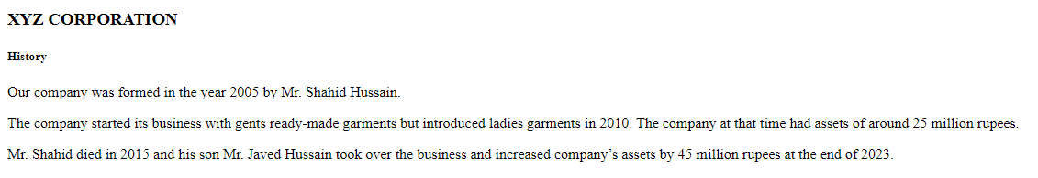

Question 2:
Write an html code which displays:

Pakistan Steel Mills
Trade Development Authority
Pakistan Cricket Control Board

When click on each of them, will display appropriate website.
Find out their URLs from NET yourself.

Code

<!DOCTYPE html>
<html lang="en">
<head>
<meta charset="UTF-8">
<meta name="viewport" content="width=device-width, initial-scale=1.0">
<title>Organizations</title>
</head>
<body>
<ul>
<li><a href="https://www.paksteel.com.pk" target="_blank">Pakistan Steel Mills</a></li>
<li><a href="https://www.tdap.gov.pk" target="_blank">Trade Development Authority</a></li>
<li><a href="https://www.pcb.com.pk" target="_blank">Pakistan Cricket Control Board</a></li>
</ul>
</body>
</html>

Output
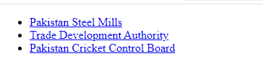

Question 3:
Write an html code which displays the following home page:

ABC STATIONERS
===============
About Us
Our Products
Announcements
Careers
Contact Us

About Us, Our Products, ….. are web pages which are linked with this home page.
Fill-up appropriate information in these pages.

Code

<!DOCTYPE html>
<html lang="en">
<head>
<meta charset="UTF-8">
<meta name="viewport" content="width=device-width, initial-scale=1.0">
<title>ABC Stationers</title>
</head>
<body>
<h1>ABC STATIONERS</h1>
<hr>
<ul>
<li><a href="about.html" target="_blank">About Us</a></li>
<li><a href="products.html" target="_blank">Our Products</a></li>
<li><a href="announcements.html" target="_blank">Announcements</a></li>
<li><a href="careers.html" target="_blank">Careers</a></li>
<li><a href="contact.html" target="_blank">Contact Us</a></li>
</ul>
</body>
</html>

Output

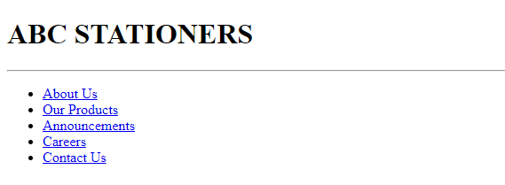

about.html

<!DOCTYPE html>
<html lang="en">
<head>
<meta charset="UTF-8">
<meta name="viewport" content="width=device-width, initial-scale=1.0">
<title>About Us</title>
</head>
<body>
<h1>About Us</h1>
<p>ABC Stationers was established in 1990 to provide quality stationery products. We are a trusted supplier to schools, offices, and individuals across the region.</p>
</body>
</html>

Output
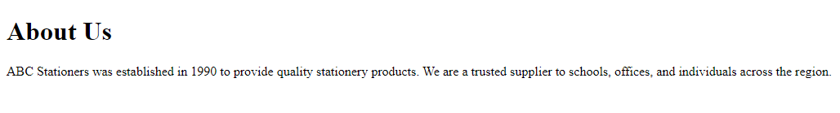

products.html

<!DOCTYPE html>
<html lang="en">
<head>
<meta charset="UTF-8">
<meta name="viewport" content="width=device-width, initial-scale=1.0">
<title>Our Products</title>
</head>
<body>
<h1>Our Products</h1>
<ul>
<li>Notebooks and Diaries</li>
<li>Pens and Pencils</li>
<li>Office Supplies</li>
<li>Art Materials</li>
<li>School Supplies</li>
</ul>
</body>
</html>

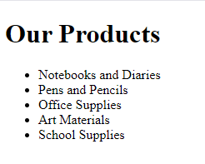
Output

announcements.html

<!DOCTYPE html>
<html lang="en">
<head>
<meta charset="UTF-8">
<meta name="viewport" content="width=device-width, initial-scale=1.0">
<title>Announcements</title>
</head>
<body>
<h1>Announcements</h1>
<p>We are excited to announce our year-end sale starting December 1st! Enjoy up to 30% off on selected items.</p>
</body>
</html>

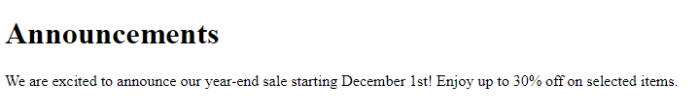
Output

careers.html

<!DOCTYPE html>
<html lang="en">
<head>
<meta charset="UTF-8">
<meta name="viewport" content="width=device-width, initial-scale=1.0">
<title>Careers</title>
</head>
<body>
<h1>Careers</h1>
<p>Join our team! We are currently hiring for the following positions:</p>
<ul>
<li>Sales Representative</li>
<li>Inventory Manager</li>
<li>Customer Support Specialist</li>
</ul>
<p>Send your resume to careers@abcstationers.com.</p>
</body>
</html>

Output
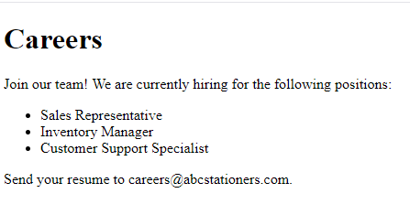

contact.html

<!DOCTYPE html>
<html lang="en">
<head>
<meta charset="UTF-8">
<meta name="viewport" content="width=device-width, initial-scale=1.0">
<title>Contact Us</title>
</head>
<body>
<h1>Contact Us</h1>
<p>Email: info@abcstationers.com</p>
<p>Phone: +92-123-4567890</p>
<p>Address: 123 Market Street, Karachi, Pakistan</p>
</body>
</html>

Output
